Research has shown that the single most important thing that we can do to help a child acquire language and instil a love of learning, is to listen to children read on a regular basis. When someone reads to a child, they are exposing that child to more than just the words on the page; they are demonstrating proper speech patterns, the basics of how a book is read and the excitement and love that reading brings. To be able to enjoy the endless opportunities books have to offer, children need to be able to decode words accurately. This is where phonics comes in. Reading is one of the most important skills we teach children in school, and therefore to develop your child into an amazing reader, we have purchased a reading programme called Read Write Inc. to ensure your child develops their reading skills in a fun and meaningful way.
What is RWI phonics?
Read Write Inc. (RWI) is a phonics-based programme, which helps children learn to read whilst also developing a wide range of vocabulary and encouraging a love of stories. It was developed by Ruth Miskin and more information on this can be found at www.ruthmiskin.com.
Who is Read Write Inc. for?
The Read Write Inc. programme is for primary school children learning to read. Children will begin the programme in Nursery and will remain on the programme until they are reading at expected standard for year 2. Our aim is for most children to be off the programme by the end of Year 2, however some children will remain on the programme in Years 3 and 4.
How will it work?
Nursery
Children will be exposed to some of the rhymes for the set one sounds in preparation for RWI in the term before they start Reception. Alongside this, the children will have lots of games that promote oral blending. Children will share stories together to develop their love of reading.

Year R
Children will be taught a sound a day and will be assessed regularly by their class teachers. When they have reached an appropriate level they will be grouped according to their reading level, and will be taught for up to an hour, when they will start reading and writing alongside learning the new sounds.
Years 1 – 2 (and any individuals in Y3 and 4, as needed)
The children will complete reading and writing activities for an hour each day, grouped according to their reading level. Children will be grouped according to their stage not their age, so classes will be mixed and taught by different teachers/teaching assistants.
What does the RWI teaching process look like?
Children are first taught the pure ‘set 1 sounds’ so that they will be able to blend the sounds in words more easily. In school we call this ‘Fred Talk’. We do not use letter names at this stage; we simply focus on the sounds that are used to sound out words. At this stage, the children are not only taught the ‘sound’ the letter makes, but also how to form the letter, using a rhyme and picture prompt. The children will then move on to more complex sounds and alternatives in Set 2 and 3 speed sounds.
What books will the children take home?
Each week the children will take a copy of the book that they have been learning in class, home. They will be familiar with the story, so we ask parents to follow the instructions in the book to consolidate their learning. Along with this, the children will also take another storybook home linked to the colour of their group. This means that they will only receive two books a week. Re-reading the books over the period that they have them at home will develop their fluency of reading and their familiarity of key words within the book. Parents are also encouraged to share other books at home together as well, to develop their love of reading.
As the Read Write Inc. books are different from the books have been reading in previous years, the books on Bug Club will not correspond with the new books in the programme. Therefore, children will only use Bug Club once they have reached the yellow reading books in the Read Write Inc. programme. The class teachers will allocate books when they have reached this stage.
How can parents help children at home?
- Establish a routine to include reading at least 4 times a week.
- Have fun with the Fred talk at home e.g. where is your c-oa-t? Time for b-e-d!
- Encourage their child to “Fred Talk” or sound out any unfamiliar words.
- Recognise “red words” together- “Remember you can’t Fred a red!”
- Comment in their child’s Home School Reading record to keep a dialogue going with the class teacher.
- Read as many stories to their child as they can. Traditional tales, stories from other cultures, poetry, their favourite story- talk about the stories with them.
- Explain the meaning of new words.
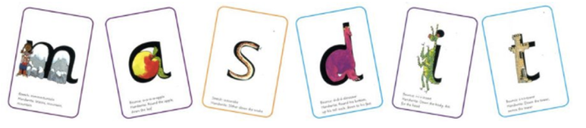
When using RWI to read the children will:
Learn to read effortlessly so that they can put all their energy into understanding what they read.
Learn 44 sounds and the corresponding letter/letter groups using simple picture prompts.
Learn to read words using Fred Talk.
Learn to read words by blending the sounds together.
Read lively stories featuring words they have learnt to sound out.
Show that they understand the stories by answering 'Find It' and 'Prove it' discussion questions.
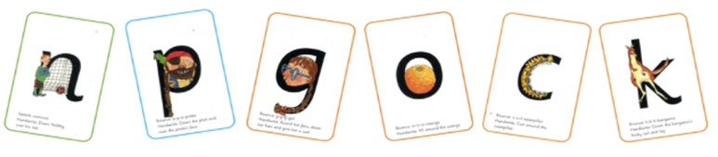
When using RWI to write the children will:
Spell effortlessly so that they can put their energy into working out what they want to write.
Learn to write the letters/letter groups which represent the 44 sounds (graphemes).
Learn to write words by saying the sounds in Fred Talk.
Learn to write simple and then increasingly complex sentences.
Compose a range of texts using discussion prompts.
Compose stories based on picture strips.
Write simple sentences.

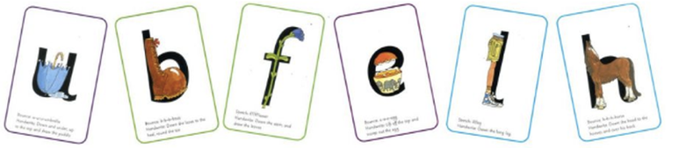

Talking
When using 'Read Write Inc' the children work in pairs to:
Answer questions to practise every activity.
Take turns talking to each other.
Give positive praise to each other.
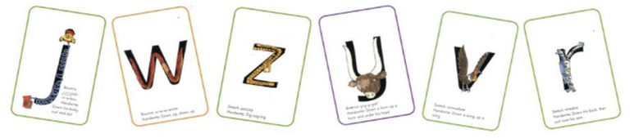
Blending
Children learn to read words by blending the letter-sounds that are in the Speed Sound sets.
Help your child learn to read words by sound-blending e.g. c-a-t = cat
Help children to say the pure sounds, as quickly as they can, and then to blend the sounds together to say the whole word.

Set 1 sounds
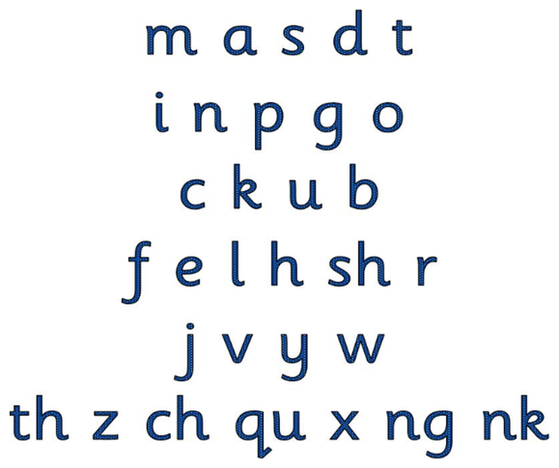

Set 2 sounds
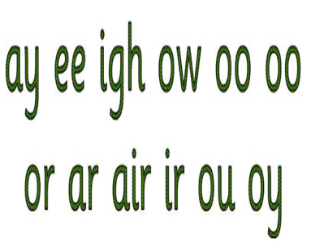
Set 3 sounds
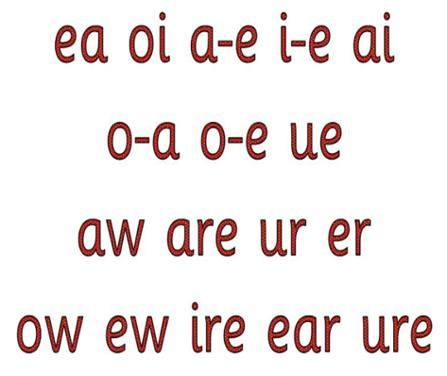
How will I know how to pronounce the phonic sounds?
https://ruthmiskin.com/en/find-out-more/parents/#lg=1&slide=2

What else can I do to help my child with their reading?
Read a variety of books (fiction, non-fiction, rhymes etc).
Discuss the different features of various books.
Talk about the books and other reading materials that you have shared.
Explain the meaning of new words.
Most importantly though, show the fun that can be gained by listening to stories and reading a range of texts. e.g. reading and then following a recipe together
Don't forget you don't have to read just books, cereal packets, shopping lists, road signs, web pages, magazines, newspapers etc are useful ways to practise reading.

Useful website links:

What is Read Write Inc phonics?
https://ruthmiskin.com/en/find-out-more/parents/#lg=1&slide=0
https://ruthmiskin.com/en/find-out-more/parents/#lg=1&slide=1

Sound pronunciation guide
https://ruthmiskin.com/en/find-out-more/parents/#lg=1&slide=2

Why read to your child
https://ruthmiskin.com/en/find-out-more/parents/#lg=1&slide=3

The Phonics Screening Check
https://ruthmiskin.com/en/find-out-more/parents/#lg=1&slide=4

10 things to think about when you read to your child
https://ruthmiskin.com/en/find-out-more/parents/#lg=1&slide=5

Simple Speed Chart
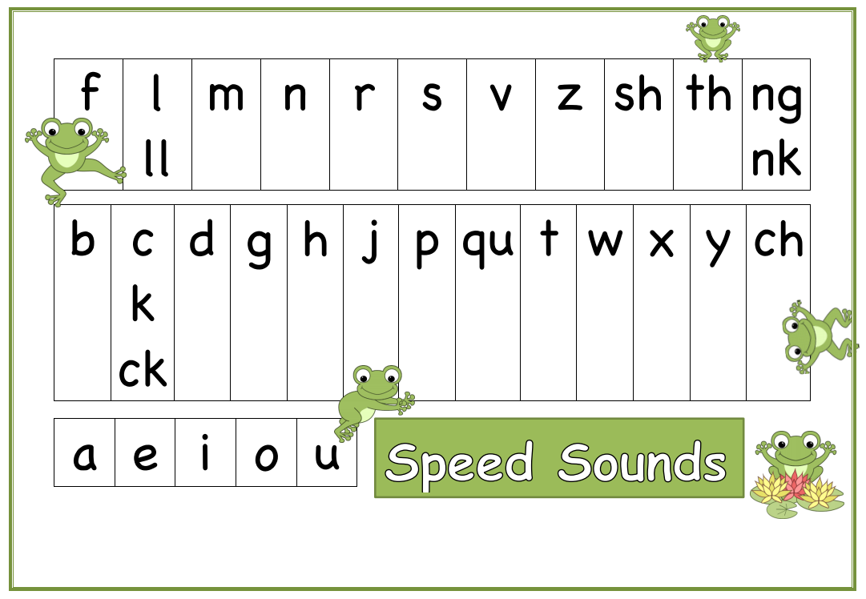

Complex Speed Chart

Letter Formation Sheet
