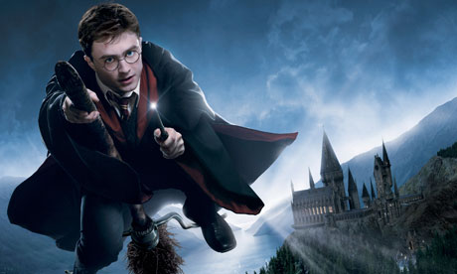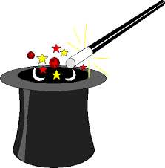

**Project Overview**

Our project this term is all about magic and how it is made in different ways. In our hook sessions the pupils will have a visit from a magician, identify magic in a Harry Potter film, create props for our Hogwarts inspired classroom and creating some magic. As writers, we will be looking closely at how magic is portrayed in films and writing our own suspense/mystery narratives. As scientists, we will be investigating how electricity is used and combine this with elements of computing to create a magic trick. In addition, we will be creating magic tricks involving soluble and insoluble materials. As mathematicians, we will investigate a range of magic tricks, in particular with card tricks.

**Project Based Learning**

Year 5

Term 1

2015-2016

**How is magic made?**

**Immersive Environment**

Our classrooms will have a Hogwarts theme, from Harry Potter and include:

* LED candles and pennants hanging from the ceiling
* Displays using magic images and shapes
* A witches cauldron, spider webs and spiders
* Parts and props from Harry Potter

**Curriculum Opportunities**

Writing

* Write stories of mystery and suspense
* Write explanations
* Learn a significant poem and write poems that convey an image

Maths

* Rigorously apply mathematical knowledge across the curriculum, in particular in science, technology and computing
* Deepen conceptual understanding of mathematics by frequent repetition and extension of key concepts in a range of engaging and purposeful contexts.

Science

* Explain how light appears to travel in straight lines and how this affects seeing and shadows.
* Examine the properties of materials using various tests.
* Look at solubility and recovering dissolved substances. Separate mixtures.
* Examine changes to materials that create new materials that are usually not reversible.

Computing

* Design and write programs that accomplish specific goals, including controlling or simulating physical systems; solve problems by decomposing them into smaller parts.
* Select, use and combine a variety of software (including internet services) on a range of digital devices to accomplish given goals, including collecting, analysing, evaluating and presenting data and information

P.E.

- Play competitive games, modified where appropriate and apply basic principles suitable for attacking and defending.

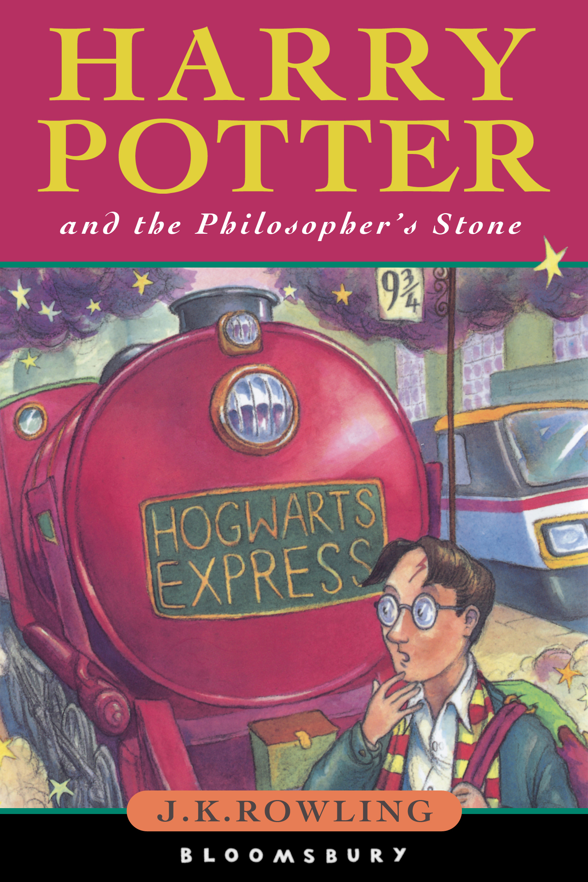

**Project Outcomes**

This project will involve the children using cross curricular skills to help them answer the essential question of:

‘***How is magic made?***’

Their final project will be creating and perfecting a magic trick.

The final exhibition will be to perform their chosen magic trick at a magic show.

**Project Timeline**

Focus 1

The magic of movies

Focus 2

The magic of maths

Focus 3

The magic of science

Focus 4

The magic of spells

Focus 5

The magic show

**Project Enhancements**

Trip

A visit to Harry Potter studios on Friday 25th September 2015.

Visitors

John Morton (magician) on Friday 17th July 2015

Jesus’ miracles workshop with Margaret Deller on Monday 2nd November 2015.

Class book

‘Harry Potter and the Philosopher’s Stone’ by J.K Rowling

Creative Home Learning

Children to make their own trick at home to perform, complete with props and writing instructions on how to perform it.

**How can you help?**

- If you feel you can help us with our project this term we would love to hear from you!

- You could read the Harry Potter novels or watch the films.

Useful websites:

- https://www.wbstudiotour.co.uk/  
- <http://magictricksforkids.org/>