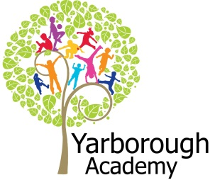

**How can we create packaging to help children keep healthy?**

**Project Overview**

Our project this term is all about designing child friendly packaging to promote a healthy lifestyle. The children will be hooked into the project by investigating current food and drink packaging to see if it is helping children to make the correct decisions about what they eat and drink. They will complete a task to count the number of tablespoons of sugar in different drinks to find out the sugar content within our everyday drinks.

The project links with current healthy eating issues and the highlight on sugar content. Children will be learning about healthy eating and healthy lifestyles through a range of focuses and activities all linking to the end product of their own child friendly packaging. The aim is to inform other children how to make healthy choices.

The children will design and make their own drinks label as their project, which they will exhibit.

As part of the focus on how to keep our bodies healthy, the children will be going on a trip to Eureka where they will investigate the body and how it works.

**Immersive Environment**

Our classrooms will have a healthy theme focus with healthy foods and the human body:

- Hansel and Gretel house- to change into a healthy home throughout the project!

- Large fruit and vegetable displays.

- Life size human body with a focus on teeth and heart.

**Curriculum Opportunities**

**Reading and Writing**

- Writing stories and plays that use the language of fairy tales and traditional tales.

- Write glossaries.

- Reading and listening to traditional tales.

-Writing instructions.

- Write labels and captions.

**Maths**

- To use statistics and tally charts.

- Addition and subtraction.

- Multiplication and division.

- Shape including 3D and properties.

- Use and apply mathematics in everyday activities.

- Measures including weighing and time.

**Science**

- Plants- identify basic structure and describe conditions for growth.

- Humans- Look at growth, basic needs, exercise, food and hygiene.

- Sound - Look at sources.

**History**

- The life of Florence Nightingale and how health has changed over the years.

**Computing**

-Designing and creating a drinks bottle label.

- Using ‘sugar smart’ app to scan barcodes and look at the content of food.

**RE**

- Christian story – Loaves and fishes.

**DT**

- Designing and creating a label.

**Art**

-Painting of still life work by Van Gogh.

**PE**

- Use basic movements and observe the effects on our bodies.

**Project Based Learning**

Year 1

Term 3

2015-2016

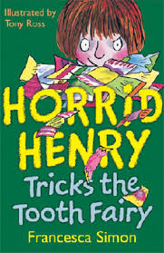

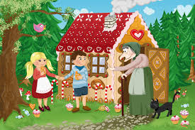

**How can you help?**

If you feel you can help us with our project this term we would love to hear from you, especially any visitors you may know who can share information around healthy eating or bodies.

You can look at the change for life website to find out about healthy lifestyles and use the ‘Sugar Smart App’:

<http://www.nhs.uk/change4life/Pages/change-for-life.aspx>

**Project Enhancements**

**Trip**

-A trip to Eureka in Halifax on Thursday 26th May 2016

**Class books**

-Hansel and Gretel.

- Horrid Henry tricks the Tooth Fairy.

**Creative Home Learning**

- To create a photo diary of healthy balanced meals cooked at home with their adult.

**Project Outcomes**

This project will involve the children using cross curricular skills to help them answer the essential question of:

‘***How can we create packaging to help children keep healthy?***

The final project will enable the children to share their drinks package they have created over the course of the project. They will be able to invite their parents, governors and health care specialists to pitch their packaging design to see if they agree it would be a useful label to promote healthy choices for children.

The final exhibition will be to hold a ‘design showcase’ in the school hall.

**Project Timeline**

Focus 1

What does your food/ drink contain?

Focus 2

How has our understanding of health changed over the years?

Focus 3

What do our bodies need to be healthy?

Focus 4

How can we make our food/ drink healthier?

Focus 5

How can we inform children to make the best choices?

Focus 6

How can we make packaging for other children?