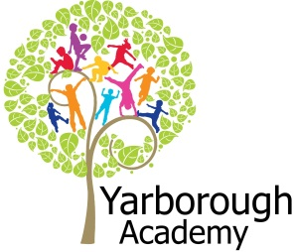

**Immersive Environment**

Both classrooms will be fully immersed into a dragons land featuring imaginary and real dragons. There will be dragon caves and flying dragons.

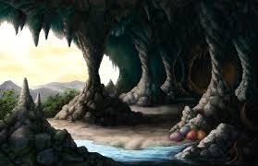

**Project Overview**

Our project this term is all about looking at real and imaginary dragons and thinking about how we can help bearded dragons that are abandoned as pets. The children will be launched into this project by discovering dragon footprints and receiving a letter from George who features in our novel study asking them to help him find his missing dragons. The children will create missing posters and write simple instructions to help George find them.

As scientists they will be finding out about materials and their properties before choosing which material will be the best to help the dragons stop their ice eggs from melting. They will also consider how dragons fly and will investigate the best wing design to help a wingless dragon fly home.

As researchers, the children will look at how dragons are represented in fiction and in religion before reporting back to George from our novel study why most people are afraid of dragons.

As readers and writers the children will then be immersed into our novel study ‘Dragon Machine’. The children will use images to focus on descriptions of dragons and imaginary lands before writing their own descriptive piece. They will also use their reading skills to find information in books and on the Internet about real life dragons, which can be used in their writing. Further along, as writers they will be writing a report about dragons in real life thinking about their habitat, appearance and diet.

As artists, we will design what we think a dragon should look like and study the techniques used by the artist Yulia Brodskaya to create pieces of artwork to sell at our dragon convention. The children will also use these skills and further art techniques to create group pieces of artwork to display at Lincolnshire Wildlife Park.

Our final exhibition will be a Dragon Convention in school to show case our learning and to raise money to donate to the Lincolnshire Wildlife Park to support their work around Bearded Dragons.

**How Can We Help The Dragons?**

**Project Based Learning**

Year 2

Term 1

2017-2018

**Curriculum Opportunities**

**Writing**

Write stories with imaginary settings.

Write labels.

Write lists.

Write non-chronological reports.

Present information

**Mathematics**

Handle data in practical contexts.

Use and apply in practical contexts a range of measures, including time.

**Communication**

Engage in meaningful discussions in all areas of the curriculum.

**Reading**

Listen to a range of texts.

Use the class and school libraries.

• Become familiar with a wide range of texts of different lengths.

**Science**  
Identify, name, describe, classify, compare properties and changes.

Describe basic movements.

**Habitats**

• Look at the suitability of environments and at food chains.

**Animals and humans**

• Identify, classify and observe.

• Look at growth, basic needs, exercise, food and hygiene.

**All living things**

• Investigate differences.

**Art**

Use experiences and ideas as the inspiration for artwork.

Share ideas using drawing, painting and sculpture.

Explore a variety of techniques.

Learn about the work of a range of artists, artisans and designers.  
**Computing**

Organise, store, manipulate and retrieve data in a range of digital formats.  
**R.E**

Study other religions of interest to pupils.  
**Geography**

Investigate the world’s continents and oceans.

Use world maps, atlases and globes.

**Project Timeline**

Focus 1 Imaginary Dragons

– Descriptive piece of writing about a dragon in an imaginary setting

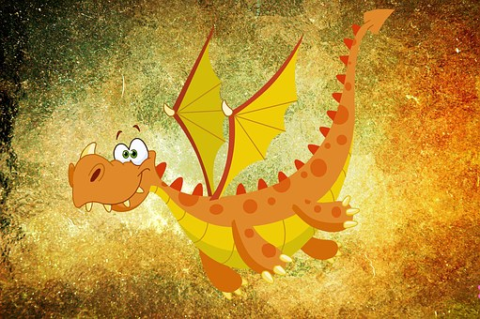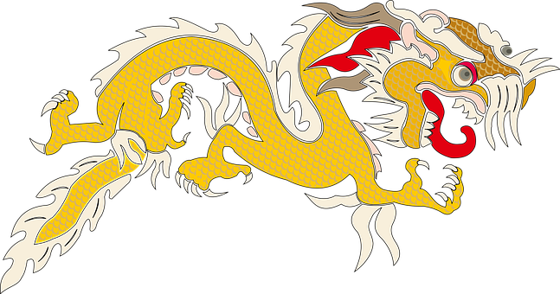

Focus 2 -Real Dragons

Report writing about their favourite type of real dragon

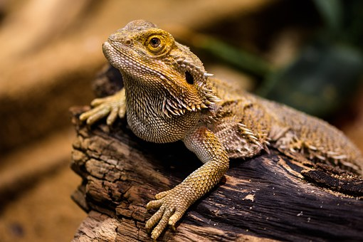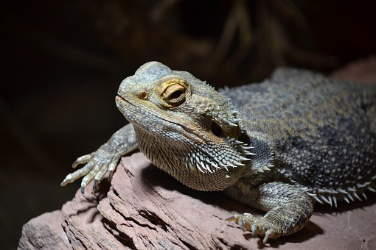

Focus 3

How do I see dragons?

- Creating pieces of artwork to sell in order to raise money for bearded dragons at Lincolnshire Wildlife Park



**Project Enhancements**

Trip

We will be visiting Lincolnshire Wildlife Park, as a hook to inspire our children for this project. The trip will be on Wednesday 11th October.

Visitors

We would love to hear from anybody who might have a pet bearded dragon.

Class book

The Dragon Machine by Helen Ward

Creative Home Learning

We will be asking the children to create their own Dragon Machine.

**Project Outcomes**

This project is designed for the children to answer the essential question of ‘How can we help the dragons?’

Throughout the project, the children will be working towards understanding that dragons can be imaginary and real. They will be developing an understanding of how they are represented in order to create a piece of artwork as the final outcome. This artwork will be sold in order to raise money to help the bearded dragons at Lincolnshire Wildlife Park. Some of our collaborative artwork will be displayed at the park to recognise the children’s contribution.

Our final exhibition will be a dragon convention in which we hope to encourage everyone to dress up. The children will showcase their learning and sell their artwork in order to raise money for the Lincolnshire Wildlife Park. This will take place on Wednesday 29th November.

**How can you help?**

If you feel you could help us with this project, we would love to hear from you.

Here are some useful websites that will help you become more informed about dragons:

<http://www.lincswildlife.com/>

<http://www.nationalgeographic.com/animals/reptiles/k/komodo-dragon/>