

**Curriculum Opportunities**

Personal, Social and Emotional Development

Being more outgoing towards unfamiliar people and more confident in new social situations.

Showing an understanding of boundaries and routines

Begin to solve problems

Communication and Language

Listening to stories with increasing attention and recall

Beginning to understand ‘why’ and ‘how’ questions.

Understanding more complex sentences

Using simple sentences when speaking

Physical Development

Giving meaning to marks that they make and ascribing marks they see in different places

Moves freely and with pleasure and confidence in a range of ways, such as slithering, shuffling, rolling, crawling, walking, running, jumping, skipping, sliding and hopping.

Literacy

Listening to a range of texts

Listening and joining in with stories and poems, one-to-one and also in small groups

Orally blending CVC words

Mathematics

Counting objects to 10 and above

Using the language of more/ fewer when comparing amounts

Counting in a range of practical contexts

Understanding the World

Shows interest in different occupations and ways of life.

Shows care and concern for living things and the environment.

Can talk about some of the things they have observed such as plants, animals, natural and found objects.

Finding out about different cultures and traditions

Expressive Arts and Design

Constructing with a purpose in mind, using a variety of resources.

Manipulating materials to achieve a planned effect

Singing to themselves and making up songs

**Immersive Environment**

The classroom will be divided into the following areas: creative, artistic, construction, investigation, small world, home, listening, reading, fine motor, computing and games.

These areas will be changed regularly to immerse children into the focus of that week.

**Project Overview**

Our summer term poject is “What could I be when I grow up?” We will be learning about a variety of different job roles. Our exhibition will be a stay and play session in our classroom. This will showcase everything we have learnt and will give you and your child the opportunity to participate in a variety of activities relating to the project.

The children will be immersed into their learning every week with a ‘wow’ activity relating to the focus. For each focus we will create a new role play area for our classroom ready for our exhibition. For our first focus we will have a message from Mr Jessup telling explaining that he needs a new teacher. We will then discuss what we are good at and then teach it to our group! For our second focus we will be looking at the roles of the police. We will have a visit from Andy our PCSO officer and help him solve a crime! We will also use our finger prints to create pictures. We will then investigate the job role of and RNLI worker. We will create a boat using a variety of different materials to help rescue a teddy from a paddling pool. Next we will concentrate on the job role of a Gardener. We will help Mr Bloom find out what mini beasts live in our garden. We will then have a Fathers day stay and play. This will involve inviting a special man in our lives to come and plant a sunflower, build dens and mark make to help brighten our garden up!

Next we will focus on the role of a vet. We will help Miss Fleet’s tortoise feel better by picking food that is safe for her from our school field. For the final part of our project we will look at the role of parents. We will find out about weddings and then have one of our very own. We will write wedding invitations and then get dressed up for the big day! After that we will look at the responsibility of looking after a baby. We will be having a baby crèche stay and play for all of the mums and dads with babies. We will choose toys we think are appropriate for them and also sing them our favourite nursery rhyme. Our exhibition will be on Tuesday 11th July and will be in our class room.

**What could I be when I grow up?**

**Project Based Learning**

Nursery

Summer Term

**Project Enhancements**

Trips and Visitors

We will be having visits from a PCSO officer, the RNLI, an ice cream van and Canon Peter Mullins. We will also be having a stay and play session for Fathers day and a stay and play session for babies and their parents.

Class books – Topsy and Tim, Burglar Bill, A Day in the Life of a Police Officer, The Lighthouse Keepers Lunch, Little Bears Little Boat, Who Sank the Boat, Lost and Found, Izzy the Ice Cream Fairy, From Milk to Ice Cream, Superworm, The Hungry Caterpillar, The Very Busy Spider, Spider Sandwiches, The Hare and the Tortoise, Six Dinner Sid, Mog, Hairy Maclarey Rumpus at the Vets, The Scarecrows Wedding, Spot Loves His Mum, My Mum and Dad Make Me Laugh

Clips/ Videos online – Alphablocks, Peppa Pig- Police Car, Come Outside, Doc McStuffin, Count to 100 – Jack Haartman

Cbeebies – Musical Maddie, Lets Play, Old Jack’s Boat Stories, Paper Boat, Bottle Boat Mr Bloom, Storm, My First Boat Trip, My First Garden, Ben and Holly goes to the Vet, My First Brother, My First Sister, My First Wedding

Creative Home Learning – Can you practise something you are good at to teach to your group? i.e. dancing, football, counting, drawing a person

**Project Outcomes**

This project will involve the children using cross-curricular skills to help them answer the essential question of “What could I be when I grow up’’

The final exhibition will be on Tuesday 11th July at 9.30 (morning children) and 2pm (afternoon children) This will be an opportunity for you to participate in a variety of activities relating to our project with your child.

**Project Timeline**

Focus 1

Teachers

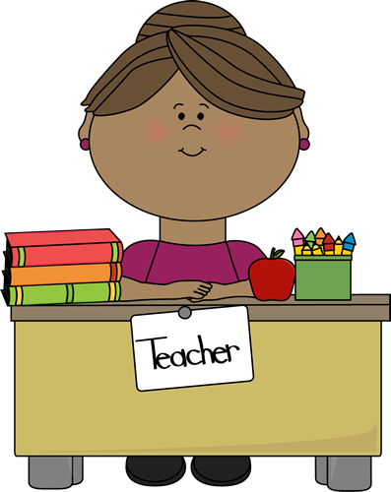

Focus 2

The Police



Focus 3

RNLI



Focus 4

Ice Cream Sellers



Focus 5

Gardeners



Focus 6

Vets



Focus 7

Parents



**How can you help?**

If you feel you can help us with our project this term we would love to hear from you.

You can also help with the project by doing the following at home:

* Planting seeds and letting your child help in the garden
* Talking about different occupations
* Letting your child help you with jobs to understand the role of a parent
* Talking about things that they are good at
* Discussing right and wrong behaviour

Useful website for parents:

[www.cbeebies.co.uk](http://www.cbeebies.co.uk), <http://www.norfolkwisekids.co.uk/fact-file/police-vehicles.aspx>, <http://www.nickjr.co.uk>