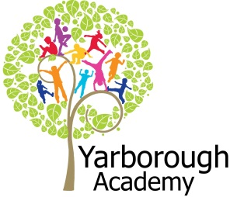

**Curriculum Opportunities**

Personal, Social and Emotional Development

Forming special friendships

Selecting and using resources with help

Showing an understanding of boundaries and routines

Communication and Language

Listening to the noises adults make when they read stories

Showing an interest in play with sounds, songs and rhymes.

Understanding more complex sentences

Using simple sentences when speaking

Physical Development

Literacy

Repeating words or phrases from familiar stories.

Listening and joining in with stories and poems, one-to-one and also in small groups

Distinguishing between the different marks they make.

Mathematics

Selecting a small number of objects from a group when asked, for example, *‘please give me one’, ‘please give me two’.*

Realising that not only objects but anything can be counted

Noticing simple shapes and patterns in pictures

Understanding the World

Completing project related activities on the iPads

Talking about the magic we have observed

Looking at similarities, differences, patterns and change

Looking at different occupations and ways of life

Recognising and describing special events for family or friends

Expressive Arts and Design

Making a magic wand

Creating a sparkler out of different materials

Learning a variety of new songs and dances

Using our imaginations in our play

Role playing different characters

**Project Overview**

Our project until Christmas is “What is magic?”

The children will be immersed into their learning every week with a ‘wow’ activity relating to the focus. After each focus we will add our items into our magic boxes ready for our end of term magic show. This will be a chance for you to see all of our learning and for us to perform our magic for you! For our first focus we will have a message from Mr Jessup telling us he’s seen a wicked witch! We will then make magic wands and think of our own spell to get rid of her. We will also have a Halloween party! For our second focus we will be looking at the magic of bonfire night. We will be making our own sparklers out of sparkly material to mark make with. We will then have our own bonfire night at the end of the week were we will eat hotdogs and chocolate apples! After that we will look at witches and their magic. We will change our role play corner into a witches den so we can pretend to make ghastly spells. We will then make our own potion using a variety of gruesome ingredients! We will then investigate the magic of colour. We will make hidden marks on paper and then add paint to reveal them! Next we will focus on the magic of winter. We will create our own wintery scene in a bottle and add magic snow to show you at our magic show!

In addition to the project we will look at the magic of Christmas! We will be learning Christmas songs, doing Christmas crafts and posting our letters to Santa. We will also have our Christmas concert for you to attend.



**Immersive Environment**

The classroom will be divided into the following areas: creative, artistic, construction, investigation, small world, home, listening, reading, fine motor, computing and games.

These areas will be changed regularly to immerse children into the focus of that week.

**What is magic?**

**Project Based Learning**

Nursery

Half Term 2

2016/2017

**Project Timeline**

Focus 1

The magic of Halloween



Focus 2

The magic of bonfire night



Focus 3

The magic of witches

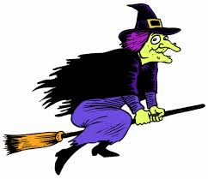

Focus 4

The magic of colour

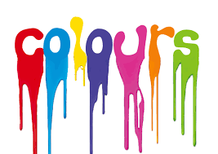

Focus 5

The magic of winter



Focus 6

The magic of Christmas



**How can you help?**

If you feel you can help us with our project this term we would love to hear from you. We would love visits from anyone who is good at magic!

You can also help with the project by doing the following at home:

* Talking about special events in your family such as Halloween and Bonfire night
* Using the language of magic to help with your child’s vocabulary i.e. abracadabra, alakazam
* Talking about seasons and their change
* Talk about different colours and what happens when you mix them

Useful website for parents:

<http://roomonthebroom.com>

<http://www.bbc.co.uk/cbeebies> (search magic)

**Project Enhancements**

Trips and Visitors

We will be having Mr Shiney come in to perform a magic show. We will also be posting our letters to Santa at the local post box.

Class books – Cinderella, The runaway pumpkin, The biggest pumpkin ever, Spider sandwiches, Topsy and Tims bonfire night, The owl that was afraid of the dark, Room on the broom, The magic porridge pot, Hansel and Gretel, Rapunzel, Winnie the witch, The colour thief, Elmer and the rainbow, The princess and the wizard, I do not eat the colour green, One starry night, Magic sky, One snowy night, Stick man, Elmer in the snow, The snowman, The gruffalo’s child, The jolly postman, Spots first Christmas, The elves and the shoemaker.

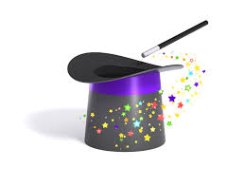

**Project Outcomes**

This project will involve the children using cross-curricular skills to help them answer the essential question of “What is magic?”

The final exhibition will be on the 9th December. This will be an opportunity for your child to perform a magic show for you. The exhibition will take place in either our classroom or the school hall.

