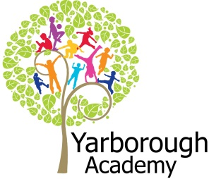

**How Can We Recreate Alice’s Wonderland?**

**Project Overview**

Our project this term is all about Alice’s Wonderland and how we can recreate our own version of this. The children will be hooked into their learning by investigating the footprints left by the white rabbit and analysing the box of props that he has left behind. We will also be watching the 1951 version of the film and creating some of the pieces of our immersive environment.

As mathematicians, we will shrink ourselves into wonderland and learn how to find our way around. As readers and writers, we will examine the characters and take inspiration from the book in order to create a new character and new area of wonderland. As scientists, we will identify plants in wonderland, look at how they are suited to the environment and design our own plants to go into wonderland. As part of the project we will design and make props for the Mad Hatters tea party. We will also become experts at making jam tarts!

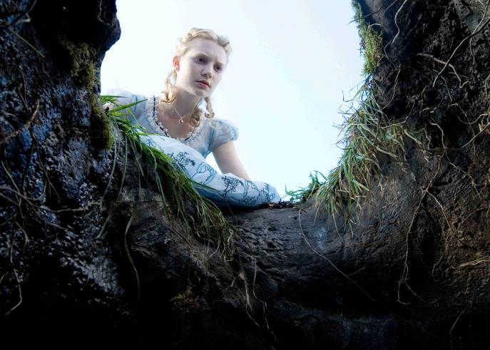 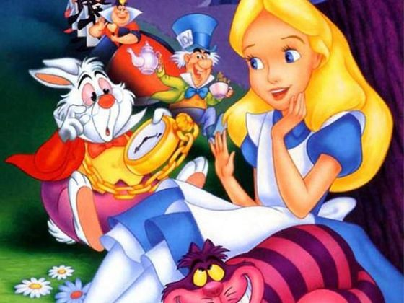

**Project Based Learning**

Year 4

Term 1

2015-2016

**Immersive Environment**

Our classroom will have a Wonderland theme and will include:

* A rabbit hole
* A woodland
* Wonderland characters
* Mad Hatters top table
* Playing cards

Curriculum Opportunities

Maths

- Use and apply measures to increasingly complex contexts.

- Describe position, direction and movement in increasingly precise ways.

English

- Write poems that convey an image (simile, word play, rhyme and metaphor).

- Learn by heart and perform a significant poem

- Write arguments.

- Write instructions.

- Write stories of adventure.

- Take part in conversations about books.

- Listen to and discuss a wide range of texts.

- Read and listen to whole books.

Art

- Use experiences, other subjects across the curriculum and ideas as inspiration for artwork.

- Improve mastery of techniques.

Computing

- Select, use and combine a variety of software on a range of digital devices to accomplish given goals.

- Design and write programs that accomplish specific goals, including controlling or simulating physical systems; solve problems by decomposing them into smaller parts.

- Use sequence, selections and repetition in programs; work with variables and various forms of input and output; generate appropriate inputs and predicted outputs to test programs.

Science

- Look at the effect of diet and exercise and drugs.

- Look at adaptation to environments.  
- Look at classification of plants.

Geography

- Use the eight points of a compass, four-figure grid references, symbols and keys.

P.E

- Take part in outdoor and adventurous activity challenges both individually and within a team.

DT

- Develop design criteria to inform the design of functional and appealing products that are fit for purpose, aimed at particular individuals or groups.

- Select from and use a wider range of materials and components, including construction materials, textiles and ingredients, according to their functional properties and aesthetic qualities.

- Understand and apply the principles of a healthy and varied diet.

Music

- Improvise and compose music using the inter-related dimensions of music separately and in combination.

R.E.

- Study the beliefs, festivals and celebrations of Christianity.



**How can you help?**

If you feel you can help us with our project this term we would love to hear from you.

Useful websites:

<http://www41.homepage.villanova.edu/vanessa.cohen/1040/PE/>

<http://www.alice-in-wonderland.net>

Useful texts to read include:

- Alice in Wonderland by Lewis Carroll

- Through the Looking Glass by Lewis Carroll

**Project Enhancements**

Trip

Exhibition at Classroom in the Woods

Elder – Friday 27th November 2015

Sycamore – Monday 30th November 2015

Visitors

Drama Workshop by One Day Creative – Tuesday 3rd November 2015

Class book

Alice in Wonderland by Lewis Carroll

Creative Home Learning

Wonderland in a shoebox

Creating props for the Mad Hatter’s Tea Party

**Project Outcomes**

This project will involve the children using cross-curricular skills to help them answer the essential question of ‘How can we recreate Alice’s Wonderland?’

Their final project will be designing and making the Mad Hatter’s Tea Party including props, food, costumes, invitations and music.

The final exhibition will be a journey through our wonderland and a Mad Hatter’s Tea party at Classroom in the Woods. This will include the children sharing poetry, music and extracts from their own stories.

**Project Timeline**

**Focus 1**

**Shrink Me into Wonderland**

- Scaling themselves down to fit down the rabbit hole.

**Focus 2**

**Meet and Greet**

- Exploring the characters of the Cheshire Cat and the Caterpillar

**Focus 3**

**Explore My Way Through Wonderland**

- Work on position and direction. Creating a new plant to go in Wonderland.

**Focus 4**

**Characterise Me**

- Creating a new character for the story and writing a new section to add to the original.

**Focus 5**

**Time for Tea**

- Preparing for the exhibition, including creating music and making jam tarts.

**Focus 6**

**Wakey Wakey**

- Exploring the beliefs surrounding dreams and their link to morals and values.