[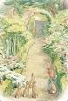](https://www.google.co.uk/url?url=https://www.pinterest.com/autumnskyler/beatrix-potter-the-story-of-peter-rabbit/&rct=j&frm=1&q=&esrc=s&sa=U&ved=0ahUKEwjk5YrFi-3SAhWHKMAKHchDA3wQwW4ILzAN&usg=AFQjCNFcZfjdGCrCRoetKQY38MsvdvH7CQ)[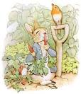](http://www.google.co.uk/url?url=http://www.ajhw.co.uk/books/book23/bp1/bp1.html&rct=j&frm=1&q=&esrc=s&sa=U&ved=0ahUKEwiWv_ydi-3SAhUlCcAKHRbiDioQwW4IHzAF&usg=AFQjCNGhftvrwGvcasgWz3vMvDhvhgJOcw)

**How can we bring Beatrix Potter to life?**

**Project Overview**

Our project this term is all about “How can we bring Beatrix Potter to life?” We will be reading the different books written by Beatrix Potter and finding ways to use her characters and some of her own interests to bring our outside areas to life.

We will investigate the author herself and take up her interest in drawing and painting and produce new spaces outside including a creative shed, an investigation area, a reading den, a construction zone, a small world area and a writing area. We will investigate rabbits and the different plants Mr McGregor would have in his garden when creating our investigation and gardening area outside. We will be learning to be a hedgehog and finding out why they need a quiet space when constructing a quiet area for Mrs Tiggy-Winkle. We will learn about the different animals that hatch from eggs and how Jemima Puddle-Duck would construct her nest to look after these eggs when creating our construction area outside. We will think about measure and size when creating a small world area for the Two Bad mice. And finally, we will use all we have learned to write our very own story, adding another addition to the Tales of Peter Rabbit when creating the writing area outside.

The children will be hooked into their learning through a nature hunt and creating our own healthy vegetable soup for animals.

**Immersive Environment**

Our classroom will be transformed into the different areas of Beatrix Potters stories including:

Garden areas

Farmland

Areas of woodland for the woodland creatures

Mr McGregor’s shed

**Project Based Learning**

Reception/FS2

Term 3

2016/2017

**Curriculum Opportunities**

Personal, Social and Emotional Development

To discuss how the animals feel when they enter new surroundings

To talk about managing feelings and behaviour in response to stories

Communication and Language

Listening carefully to stories

Responding to ideas expressed by others

Expressing our thoughts and ideas when thinking of a new story to add to Beatrix Potters collection

Physical Development

Negotiating space when playing running and chasing games when pretending to be the fox chasing Jemima Puddleduck

Moving like a hedgehog and exploring different ways of moving

Literacy

Knowing where information can be retrieved

Creating a hedgehog fact file

Making lists when guessing smells

Writing a short story about a hedgehog

Reading facts and stories about different garden animals

Creating a new story ‘The Tale of Peter Rabbit and the naughty birds’

Mathematics

Solving problems that involve addition and combining groups of 2,5, and 10 when planning out the planting of Mr McGregors garden

Investigating size and measures when creating a small world area for the Two Bad mice

Understanding the World

Investigating the habitats of garden animals and what will help them to keep safe

Creating a garden patch and investigating the changes a plant makes over time

Expressive Arts and Design

Exploring materials and textures

Investigating Beatrix Potter drawings and using watercolours to replicate these

To join materials and use what they have learnt about different media to create mini scarecrows

[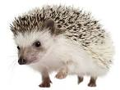](https://www.google.co.uk/url?url=https://www.southill.dorset.sch.uk/hedgehog-help-needed/&rct=j&frm=1&q=&esrc=s&sa=U&ved=0ahUKEwi0s8DRiu3SAhVHCsAKHTkcBSQQwW4IFzAB&usg=AFQjCNEaHLqfdi1wZ0eahdsoCBFyXz9EJg)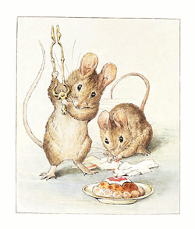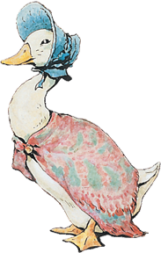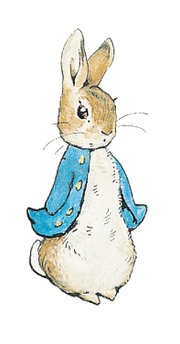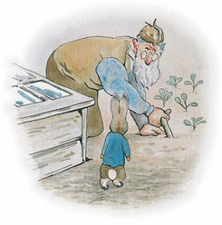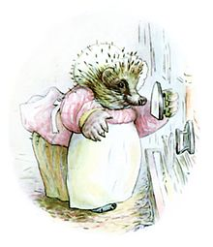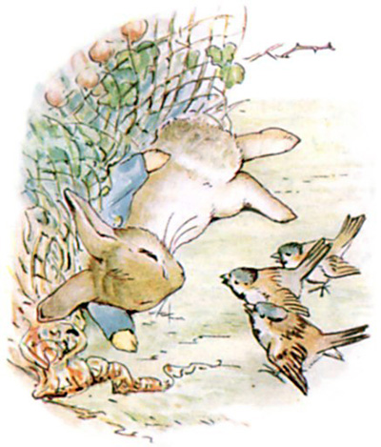

**Project Outcomes**

This project will involve the children using cross-curricular skills to help them answer the essential question of “How can we bring Beatrix Potter to life?”

The final project will be the unveiling of the outside area, which will be created throughout the project, developing different outside areas. The outside areas will be officially opened and celebrated with an afternoon tea party.

The exhibition will be held on Tuesday 11th July at 1.15.

**Project Enhancements**

Visitors – an expert about hedgehogs from ‘Hedgehog care’, a visitor from RSPB and the children from Year two who will read stories they have created about birds.

Class books –The Tale of Peter Rabbit, The Tale of Mrs Tiggy-Winkle, The Tale of Jemima Puddle-Duck, The Tale of Two Bad Mice, as well as other Beatrix Potter books, such as, The Tale of Tom Kitten, The Tale of Squirrel Nutkins, The Flopsy Bunnies, The Tale of Jeremy Fisher, The Tale of the Tailor of Gloucester.

Creative Home Learning – Can you design a family tree, adding in all of the people in your family?

**Project Timeline**

Focus 1

Being Beatrix Potter – creating a water colour painting of Peter Rabbit for our creative area outside

(The Tale of Peter Rabbit)

Focus 2

Mr McGregor’s garden – building an investigation area outside

(The Tale of Peter Rabbit)

Focus 3

Making a quiet space for a hedgehog – creating a quiet reading den/area outside (The Tale of Mrs Tiggy-Winkle)

Focus 4

Building a life-size nest – producing a construction area outside

(The Tale of Jemima Puddle-Duck)

Focus 5

Constructing a small world area for two bad mice – crafting a small world area outside (The Tale of Two Bad Mice)

Focus 6

Writing our own Peter Rabbit tale – creating a writing area outside

(The Tale of Peter Rabbit and the Naughty Birds)

**How can you help?**

If you feel you can help us with our project this term we would love to hear from you!

You can also help with the project by doing the following at home:

* Talking about what animals we can find in an English garden and how we can care for them.
* What we can do to encourage more wildlife into our gardens?

Useful website:

The Peter Rabbit page on Cebeebies has lots of stories and games:

<http://www.bbc.co.uk/cbeebies/shows/peter-rabbit>