

**What makes the seaside special?**

**Project Overview**

Our project this term is all about the seaside. We will start by learning about what lives in the sea and making pictures of the different animals. Next we will look at different boats in the sea and what their jobs are. We will create our own boats to have a boat race! After that, we will look at rock pools in order to set up own own rock pool outside. A big part of the project will be looking at things you can do at the beach, including learning some games, having a picnic and building sandcastles. We will also spend some time talking about safety at the beach and design our own Pic College posters to promote our ideas. Finally, we will learn about Punch and Judy. We will make puppets in order to retell some of the traditional tales we will look at in school. The conclusion of our project will be a short play to the parents about ‘What makes the seaside special?”

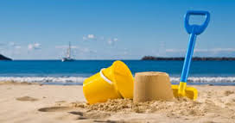

**Project Based Learning**

Nursery/FS1

Term 3

2015-2016

**Immersive Environment**

Our inside and outside classroom will have a paddling pool, sand pit, winder breakers, deck chairs, buckets and spades, beach huts, rock pool, a puppet show, fish and chip shop and lots of dressing up!

**Curriculum Opportunities**

**Personal, social and emotional development** – sharing feelings and resolving conflicts based on our class books, team games, beach safety.

**Communication and language** – sequencing stories, discussing stories, sea sounds, talking about family experiences of the seaside.

**Physical development** – running games, dressing up, ball skills, construction and handling tools, building sandcastles

**Literacy** – alliteration of sea sounds, rhyming rock pool games, retelling stories, writing postcards, making posters.

**Maths** – collecting and counting fish, shell patterns, flag sizes and shapes, construction shapes.

**Understanding the World** – talk about the seaside, compare beaches in other places, make a seaside scene on the Ipads.

**Expressive arts and design –** sea scapes, fish printing, acting out characters from stories, shell art work, joining materials for construction.

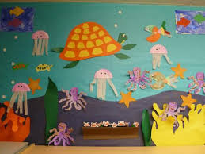

**How can you help?**

If you feel you can help us with our project this term we would love to hear from you.

Over the term you could try these things with your child:

* Go to the beach
* Eat fish and chips from a tray
* Buy an ice cream at the beach
* Send a postcard to school

**Project Enhancements**

Trip and Visitors

Visiting ice cream van

Cleethorpes seaside trip

Punch and Judy show

Class book

Rainbow Fish by Marcus Pfister

Creative Home Learning

Make a wooden spoon puppet from a traditional tale.

**Project Outcomes**

This project will involve the children using cross curricular skills to help them answer the essential question of “What makes the seaside special?”

Their final project will be a class play. The children will role play different activities you can do at the seaside. The final exhibition will be a play by the children, on Wednesday 6th July at 11am and 2pm.

**Project Timeline**

Focus 1

Who lives in the sea?

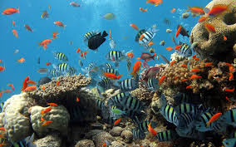

Focus 2

What is a boat for? 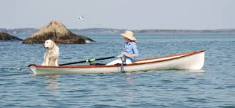

Focus 3

What do you find in a rock pool? 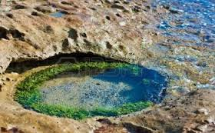

Focus 4

What do you like to do at the beach?

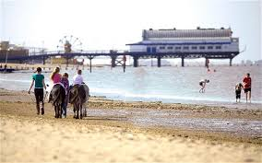

Focus 5

How do we stay safe at the beach?

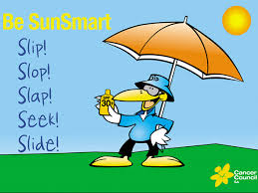

Focus 6

Who are Punch and Judy?

