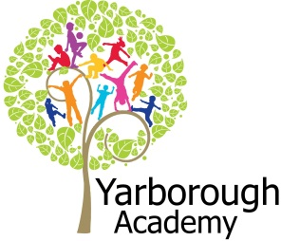

**Curriculum Opportunities**

Personal, Social and Emotional Development

Forming special friendships

Selecting and using resources with help

Showing an understanding of boundaries and routines

Communication and Language

Listening to the noises adults make when they read stories

Showing an interest in play with sounds, songs and rhymes.

Understanding more complex sentences

Using simple sentences when speaking

Physical Development

Beginning to use three fingers (tripod grip) to hold writing tools

Moving freely and with pleasure and confidence in a range of ways, such as running, jumping, skipping, sliding and hopping

Beginning to be independent in self-care, but still often needs adult support

Literacy

Repeating words or phrases from familiar stories.

Listening and joining in with stories and poems, one-to-one and also in small groups

Distinguishing between the different marks they make.

Mathematics

Selecting a small number of objects from a group when asked, for example, *‘please give me one’, ‘please give me two’.*

Reciting some number names in sequence.

Noticing simple shapes and patterns in pictures

Understanding the World

Having a sense of own immediate family and relations

Learning that they have similarities and differences that connect them to, and distinguish them from, others.

Enjoys playing with small-world models such as a farm, a garage, or a train track.

Expressive Arts and Design

Creates sounds by banging, shaking, tapping or blowing

Experimenting with blocks, colours and marks. Beginning to use representation to communicate, e.g. drawing a line and saying ‘That’s me.’

**Project Overview**

Our project until October half term is “Why am I special?”

The children will be immersed into their learning every week with a ‘wow’ activity relating to the focus. For our first focus we will have a giant Elmer in which we will decorate with different colour patches. We will record ourselves introducing who we are, which will focus on our speaking skills. We will then transfer these clips onto QR codes to go on Elmer’s body! For our second focus we will be looking at what our body can do. We will have visits from older children in the school to give us inspiration. We will then be recorded doing a variety of physical activities to go on our end of project video! After that we will look at our family. We will change our role play corner into a house so we can pretend to be different members of our family. We will also be inviting our families into school to help paint a family portrait! We will then investigate what we are good at. We will decorate superhero capes to help us discover our own super power! This could be a variety of different things such as holding a pencil, getting dressed or painting. Next we will focus on how we can be good friends. We will make a friendship book to show everybody how we can share, play and be kind.

Lastly we look at our favourite things. We will investigate our favourite foods, toys and songs to create a scrap book.

In addition to our project we will explore the seasons, starting with autumn. We will use our fabulous outdoor area to create natural pictures, collages and sculptures. We will also be going on a nature walk!

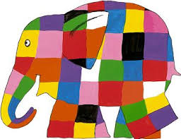

**Immersive Environment**

The classroom will be divided into the following areas: creative, artistic, construction, investigation, small world, home, listening, reading, fine motor, computing and games.

These areas will be changed regularly to immerse children into the focus of that week.

**Why Am I Special?**

**Project Based Learning**

Nursery

Half Term 1

2016/2017

**Project Timeline**

Focus 1

Who am I?



Focus 2

My body

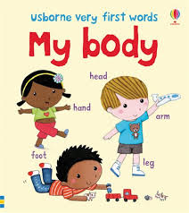

Focus 3 (a)

My family

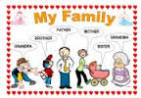

Focus 4

What is my superpower?



Focus 5

A special friend

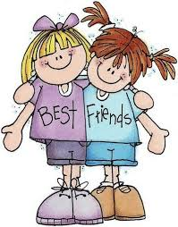

Focus 6

My favourite…

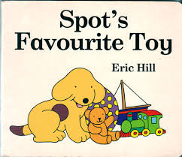

Focus 7

Autumn

**How can you help?**

If you feel you can help us with our project this term we would love to hear from you!

You can also help with the project by doing the following at home:

* Celebrating achievements
* Talking about the different members of your family
* Celebrating and praising special things they do such as dancing, drawing, painting.
* Looking at the different parts of the body

Useful website for parents: <http://www.childcarelounge.com/general-themes/i-am-special.php>

If you have an iPad or a tablet why not download the Elmer app!



**Project Enhancements**

Trips and Visitors

We will be having visits from children higher up in the school showing us their special talent. We will also be going on a nature hunt around the school to gather items for our Autumnal picture!

Class books – Spot Bakes a Cake, Spots Birthday Party, Kippers Birthday, Cliffords Birthday Party, Hand, Hand, Fingers, Thumb – Al Perkins, From Head To Toe – Eric Carle, Giraffes Cant Dance – Giles Andrea, Superworm – Julia Donaldson, Some Dogs Do – Jez Alborough, Can you – Rod Campbell, The Rainbow Fish – Marcus Pfister, The Selfish Crocodole – Michael Terry, What Friends Do best – Nathan Reed, Percy the Park Keeper – Nick Butterworth, The Busy Little Squirrel – Nancy Tafuiri,, Hodge the Hedgehog – Amy Sparkes, Spots Favourite Toy.

Creative Home Learning – Can you make an ‘I Can’ book with your child and include the things they can do over the summer? This could be riding a scooter, hopping on one leg or even going to the toilet!

**Project Outcomes**

This project will involve the children using cross-curricular skills to help them answer the essential question of “Why am I special?”

The final exhibition will be on Thursday 24th November. This will be an opportunity to watch a video of your child showcasing why they are special! The video will have a variety of different clips of the children showing their special talents.

The exhibition will take place in the school hall. There will also be a showcase of the children’s work on display for you to see.