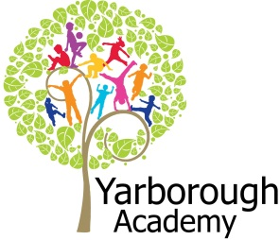

**Project Overview**

Our project this term is all about Roald Dahl and how we can bring his stories and characters to life. We will look closely at his life and what inspired him to write children’s literature.

We will investigate materials, forces and chemistry in science using links with Georges Marvellous Medicine and James and the Giant Peach.

Quentin Blake will be studied and the children will get the opportunity to create their own character and paint an illustration of the character in the style of Quentin Blake.

The children will also write their own fractured fairy tale using Roald Dahl’s Revolting Rhymes as inspiration.

We will ‘hook’ the children into this project with a day immersed in the stories of Roald Dahl completing various craft activities.

**Immersive Environment**

Our classrooms will have a Roald Dahl story theme featuring characters from:

* James and the Giant Peach
* Georges Marvellous Medicine
* Charlie and the Chocolate Factory
* The BFG and many more

**Curriculum Opportunities**

**Reading and Writing**

- A range of Roald Dahl stories

- Traditional tales

- Character descriptions

- Revolting Rhymes

- Fractured fairy tale

- Non-chronological report

**Maths**

- Addition and subtraction

- Multiplication and division

- Use of symbols (< = >)

- Position, directions and movement

- Measures including weighing and capacity

**Science**

- Physics, focusing on forces

- Chemistry, focusing on materials and chemical reactions

**Geography**

- Locating the oceans, continents and countries that the giant peach travelled through

**History**

- The life of Roald Dahl

**Computing**

- Create a ‘Morpho’

- Use ‘Puppet Pals’ to re-enact a Revolting Rhyme

- ‘Explain Everything’ to write up our science experiments

- Character immersion using ‘Do Inc’

- ‘Book Creator’ for the final annual

**RE**

- Reflection on our life and dreams

**DT**

– Creation of dream bottles, sewing potions pots and designing sweets

**Art**

– Creation of a character in the style of Quentin Blake?

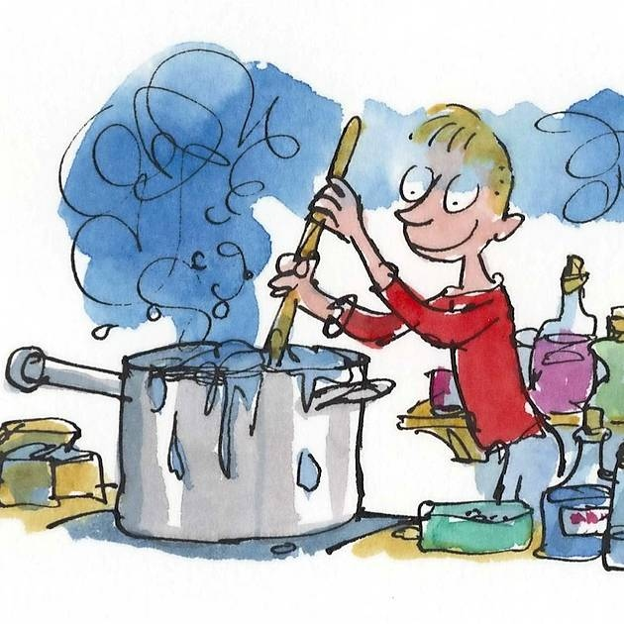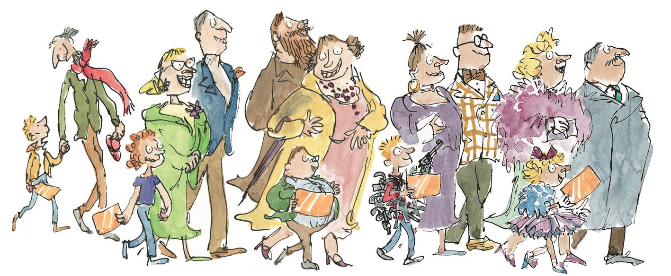

**Project Based Learning**

Year 2

Term 2

2015-2016

**How can we bring Roald Dahl books to life?**

**Project Enhancements**

**Trip**

- A trip to Magna including ‘The Kitchen Sink’ exhibition

- A trip to the library

**Class books**

- Georges Marvellous Medicine by Roald Dahl

- James and the Giant Peach by Roald Dahl

- The Twits

**Creative Home Learning**

- BFG Dream bottles

**How can you help?**

If you feel you can help us with our project this term we would love to hear from you.

To read the following books together: The BFG, Charlie & the Chocolate Factory, Matilda

Useful websites:

<http://www.>roalddahl.com to find out about Roald Dahl.

**Project Outcomes**

This project will involve the children using cross curricular skills to help them answer the essential question of:

‘***How can we bring Roald Dahl books to life?’***

The final project will enable the children to share the Roald Dahl E-Annual that they will have created over the course of the project. They will be able to invite their parents, governors and members of the community to their ‘book sharing’.

The final exhibition will be to hold a ‘book sharing’ at the library.

**Project Timeline**

Focus 1

Who is Roald Dahl?

Focus 2

Can we be scientists in our kitchen?

Focus 3

Which is the most revolting rhyme?

Focus 4

How can the enormous crocodile help us to be mathematicians?

Focus 5

Can we be artists like Quentin Blake?

Focus 6

Will a peach keep rolling down a hill without stopping?

Focus 7

Can we write a fractured fairy tale?